**Credit Card Fraud Detection**

**INTRODUCTION :**

Nowadays Credit card usage has been drastically increased across the world, now people believe in going cashless and are completely dependent on online transactions. The credit card has made the digital transaction easier and more accessible. A huge number of dollars of loss are caused every year by the criminal credit card transactions. Fraud is as old as mankind itself and can take an unlimited variety of different forms.

**Steps that are involved in credit card fraud detection:**

1. **Data Gathering**:

The first step in credit card fraud detection is to gather data about the transaction. This includes information such as the cardholder’s name, the card number, the transaction amount, and the merchant’s name.

1. **Data Preprocessing**:

Once the data has been gathered, it needs to be preprocessed to remove any irrelevant or redundant information. This step also involves converting the data into a format that can be easily analyzed.

1. **Feature Extraction**:

The next step is to extract relevant features from the preprocessed data. This involves identifying patterns and trends in the data that may indicate fraudulent activity.

1. **Model Training**:

After the features have been extracted, a machine learning model is trained on the data. The model learns to identify patterns and trends in the data that are associated with fraudulent transactions.

1. **Model Evaluation**:

Once the model has been trained, it needs to be evaluated to determine its accuracy. This involves testing the model on a set of data that it has not seen before.

1. **Deployment**:

After the model has been evaluated and found to be accurate, it can be deployed in a production environment where it can be used to detect fraudulent transactions in real-time.

These are some of the key steps involved in credit card fraud detection. However, it’s worth noting that there are many different approaches to fraud detection, and the specific steps involved may vary depending on the approach used.

**SYSTEM ARCHITECTURE**

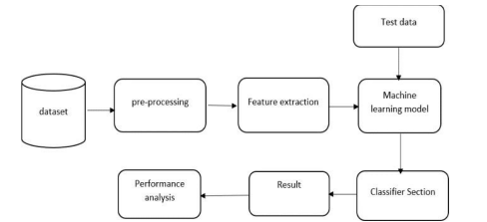

**PURPOSE OF THE PROJECT**

We propose a Machine learning model to detect fraudulent credit card activities in online financial transactions. Analyzing fake transactions manually is impracticable due to vast amounts of data and its complexity. However, adequately given informative features, could make it is possible using Machine Learning. This hypothesis will be explored in the project. To classify fraudulent and legitimate credit card transaction by supervised learning Algorithm such as Random forest. To help us to get awareness about the fraudulent and without loss of any financially.

**CONCLUSION**

Credit card fraud is a persistent problem that can lead to significant financial losses for individuals and business alike.Withthe increasing reliance on electronic payments, detecting and preventing fraud has become a crucial task for financial institutions.